## **SECURE SCAN**

## **INTRODUCTION TO THE PROBLEM STATEMENT:**

## 

## OVERVIEW

One-step way to make payments, know about an item, and much more work in one scan the technology of QR code has facilitated us. A QR code an initialism for quick response code is a type of matrix barcode or two-dimensional barcode that has become a part of our daily life in numerous ways. When we scan a QR code, it merely displays the link, which we can then follow. However, there always exists a question mark on the URL source, whether that link is secured enough.

# EXISTING SYSTEM:

There are numerous applications available for scanning QR Codes. As the QR codes are not inspected or made by a secure authority, anyone can create a QR code in a matter of seconds using simple techniques, yet this piece of code is incomprehensible to the naked eye.

The URL data type is the only scenario in which conventional QR codes can carry executable data. Because a reader would normally send the data to the application associated with the data type utilized by the QR code, these URLs may contain JavaScript code that can be used to exploit vulnerabilities in applications on the host system, such as the reader, web browser, or image viewer.

Linking to dangerous websites with browser exploits, enabling the microphone/camera/GPS and then streaming those feeds to a remote server, analysis of sensitive data (passwords, files, contacts, transactions), sending email/SMS/IM messages or packets for DDoS as part of a botnet, corrupting privacy settings, stealing identity, and even containing malicious logic such as JavaScript or a virus are all risks. These actions could take place in the background, with the user only seeing the reader open a seemingly innocuous web page.

## **OUR SYSTEM:**

Even though QR code scanner is inseparable from our daily life, many of the users are unaware of the dark sides of using this technology. One way solution is to check each and every QR code and its source and authenticity. Scanning all the QR codes around a large area, maintaining a proper database for it, and going through it each time while scanning a code is a laborious task. An easier way would be to automate this task and make it more efficient and feasible by maintaining a middleware database authenticator software. That software will work as a normal QR code scanner and on scanning verifies the code from the database and informs the user whether the code is secure or not.

## **SOFTWARE PROCESS MODEL:**

Software Processes are a set of actions that are used to specify, develop, implement, and test software systems. A software process model is an abstract representation of a process that provides a description of the process from a certain point of view.

## **V-Model:**

The software model fits for our project is “**V-model”** (a variation of Water-fall Model). V- model provides a way of visualizing how verification and validation actions are applied to early engineering works. As a software team moves down the left side of the V, basic problem requirements are refined into progressively more detailed and technical representations of the problem and its solution. Once the code has been generated, the team moves up the right side of the V, essentially performing a series of tests that validate each of the model created as the team moves down the left side.

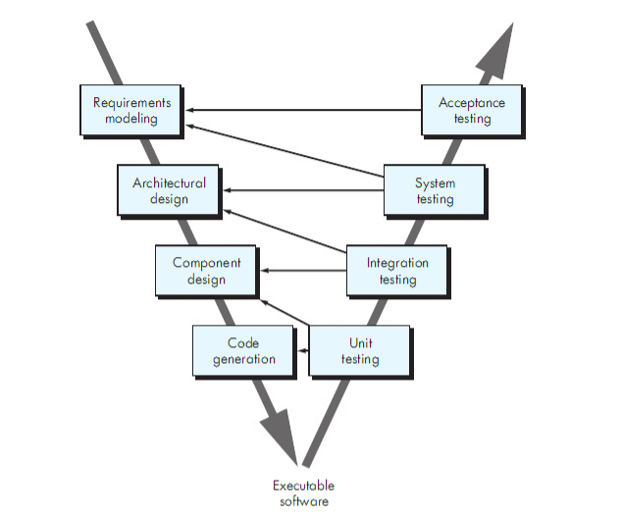

## **Why to use V-model?**

* The Secure Scanner Project is very simple and is easy to understand. We are

giving extensions to already existing applications like normal QR Code Scanners.

• V-Model is used where requirements are well understood and changes can be required iff error occurs during the testing phase in our project.

• Process, actions and results are documented but needs verification that can be done only at the time of testing.

• This project reinforces good habits: define-before-design and design-before code. This project will be built using Android-Studio IDE and Java AWT. It can be

further upgraded to IOS.

• The scope of our project precludes a purely linear process. V-Model is

best suitable for linear process.

## **Software Requirement Specification (SRS):**

A software requirements specification is a document that captures complete description about how the system is expected to perform.

* User will scan a QR to drive to some link using our app.
* Output screen will show a score out of 10 that’ll define the security of the website.
* One can create his/her profile and that will be verified.
* Verified user can request for to enlist a link as unsafe.

## **User Diagram:**

SCAN QR

USERS

LOG IN

VERIFIED USERS